Case Study Report

# Data Analytics with Power BI

**“Power BI Powered Global Terrorism”**



**Tech Saksham**

**“S.T. HINDU COLLEGE”**

|  |  |
| --- | --- |
| **NM ID** | **NAME** |
| 94C143694907C39BA6B4941506FCA4D5 | SREEJA R |

R. Uma Maheshwari

Master Trainer

# ABSTRACT

" This Paper presents a comprehensive about powered Global Terrorism using Power BI. Global Terrorism refers to the presence of terrorism and terror modules at several significant locations throughout the global. Terrorist attacks have become a serious source of risk affecting the security of the international community. Throughout the data visualisation and insights derived from various dimensions such as terrorist attacks, weapons used, target type, success rate by region, success rate by country, Taliban, explosives this analysis aims to provide a clear understanding of global terrorism. With the Use of Power BI, we can calculate the success rate by targets, weapons, attacks, country, region, and total attacks by year. The integration of advanced analytics techniques within Power BI allows for predictive modelling. The results of this research can help individuals and the government to enable a better understanding of terrorism, improve awareness to prevent terrorism and provide a solid and reliable basis and reference for joint counterterrorism in various countries and regions.

**INDEX**

|  |  |  |
| --- | --- | --- |
| **Sr. No.** | **Table of Contents** | **Page No.** |
| 1 | Chapter 1: Introduction | 1 |
| 2 | Chapter 2: Services and Tools Required | 4 |
| 3 | Chapter 3: Project Architecture | 6 |
| 4 | Chapter 4: Modeling and Result | 7 |
| 5 | Conclusion | 14 |
| 6 | Future Scope | 15 |
| 7 | References | 16 |
| 8 | Links | 17 |

**CHAPTER 1**

## INTRODUCTION

### Problem Statement

"A Terrorist or group exhibits a certain consistency in their crime characteristics and tendencies. In this study, we selected nine data types for analysis, and some data that were not important or relevant for this analysis were discarded. The region is a commom factor. For a specific organisation or individual , due to the limited scope of activities , the crime sites tend to be concentrated in a specific area . the target factor is a crucial factor affecting the terrorst attack. According to historical data and previous analysis , the attack methods of a particular terrorist exhibit similarities . The types of weapons employed also tend to be similar. This process will involves designing interative dashboards, and implementing advanced analytics techniques to provide stakeholders with a holistic view of Global Terrorism."

### Proposed Solution

"The proposed solution entails a challenges in the problem statemet , a comprehensive solution leveraging Power BI’s capacities is proposed. Firstly, Microsoft Power BI is the primary tool for data visualisation, analysis, and reporting. It allows you to connect to various data sources, prepare and clean data, and create interative dashboards and reports. Tools like Microsoft Excel, Powe ery, or SQL for data cleaning, transformation, and , modelling. These tolls are essential for preparing the raw data obtained from global terrorism for analysis. Utilise maps to display the distribution of terrorist activities across the Middle East, Europe. Create bar charts to compare success rates of terrorist attacks in each region , highlighting the high. Use line charts to visualise the prevalence of terrorist Groups in each region. Employed pie chart to demonstrate the top 5 targets if terrorist attacks in each region , such as civilian populations, public gatherings , government, institutions, and military installations. Genereted visuals like pie chart to showcase the types of weapons commonly employed in terrorist attacks across regions, including explosives , firearms, and improvised explosive devices.

By leveraging Power BItools, created interactive dashboards that offer a comprehensive overview of global terrorism trends, facilating data-driven decision-making and enhancing understanding of security challenges worldwide.

### Feature

* We’re looking at different ways terrorists carry out their actions. Think bomblings, kidnapping, or armed assaults.
* In the data what are used used by the terrorist are given as weapontype.
* Terrorism isn’t evenly spread in all over country. Some places faces more attacks than others.
* Using regions we can zooming out the map to see the terrorist attack places.
* Knowing their group names sheds light on their activities.
* Tracking the overall trend over time by total attacks in a year.
* Slicing and dicing data by country slicer.
* Quick-facts most used weapons total targets deadlist group and maximum attacks are show in cards.

### Advantages

* Using Power BI we Gather data and collect the revelent data for the project. Enusuring it clean anf organised in a way that Power BI can easily process.
* Power BI import the project data and bring in the necessary tables. And removing unneccessay data.
* Power query editor is always used to clean and transform the data .
* Utilises map maps to display the distribution of terrorist activities across the Middle East, Europe, Africa, and Asia.
* Create bar charts to compare success rates of terrorist attacks in each region , highlighting the highest rates.
* Use line charts to visualise the prevalence of terrorist Groups in each region.
* Employed pie chart to demonstrate the top 5 targets if terrorist attacks in each region , such as civilian populations, public gatherings , government, institutions, and military installations.
* Genereted visuals like pie chart to showcase the types of weapons commonly employed in terrorist attacks across regions, including explosives , firearms, and improvised explosive devices.
* By leveraging Power BItools, created interactive dashboards that offer a comprehensive overview of global terrorism trends, facilating data-driven decision-making and enhancing understanding of security challenges worldwide.

### Scope

The scope involves assessing currentPowered Global Terrorism, identifying key drivers, and evaluating the existing energy infrastructure's capacity to meet growing terrorism. It also encompasses analyzing regulatory frameworks, policies, and incentives aimed at promoting energy efficiency and renewable energy adoption. Furthermore, the scope extends to exploring technological innovations and best practices in energy management and conservation. Additionally, it involves studying socio-economic factors influencing global terrorism behavior and patterns across different sectors and regions. Moreover, Genereted visuals like pie chart to showcase the types of weapons commonly employed in terrorist attacks across regions, including explosives , firearms, and improvised explosive device. By leveraging Power BI tools, created interactive dashboards that offer a comprehensive overview of global terrorism trends, facilating data-driven decision-making and enhancing understanding of security challenges worldwide.

**CHAPTER 2**

## SERVICES AND TOOLS REQUIRED

### 2.1 Services Used

* **Power BI**: Microsoft Power BI is the primary tool for data visualisation, analysis, and reporting. It allows you to connect to various data sources, prepare and clean data, and create interative dashboards and reports.

* **Data Preparation Tools**r Qu: Tools like Microsoft Excel, Powe ery, or SQL for data cleaning, transformation, and , modelling. These tolls are essential for preparing the raw data obtained from global terrorism for analysis.

* **Machine Learning Services**:Besides Power BI, you might use additional data visualisation libraries or tools like D3.js or creating custom visualisation.

### 2.2 Tools and Software used

**Tools**

* **PowerBI**: The main tool for this project is PowerBI, which will be used to create interactive dashboards for real-time data visualization.

* **Power Query**: This is a data connection technology that enables you to discover, connect, combine, and refine data across a wide variety of sources.

**Software Requirements**

* **PowerBI Desktop**: This is a Windows application that you can use to create reports and publish them to PowerBI.

* **PowerBI Service**: This is an online SaaS (Software as a Service) service that you use to publish reports, create new dashboards, and share insights.

* **PowerBI Mobile**: This is a mobile application that you can use to access your reports and dashboards on the go.

**CHAPTER 3**

## PROJECT ARCHITECTURE

**3.1 Architecture**

### 

Here’s a high-level architecture for the project:

1. **Data Collection**: Powered Global Terrorism is collected from various sources like target types, weapon types, attack types, regions, etc...
2. **Data Storage**: The collected data is stored in a database for processing.
3. **Data Processing**: The stored data is processed the information about the target types, attack types, etc…
4. **Data Visualization**: The processed data and the results from the predictive models are visualized in real-time using Power BI. Power BI allows you to create interactive dashboards that can provide valuable insights into the data.
5. **Data Access**: The dashboards created in Power BI can be accessed through Power BI Desktop, Power BI Service (online), and Power BI Mobile.

**CHAPTER 4**

## MODELING AND RESULT

**Transform data**

**Append**

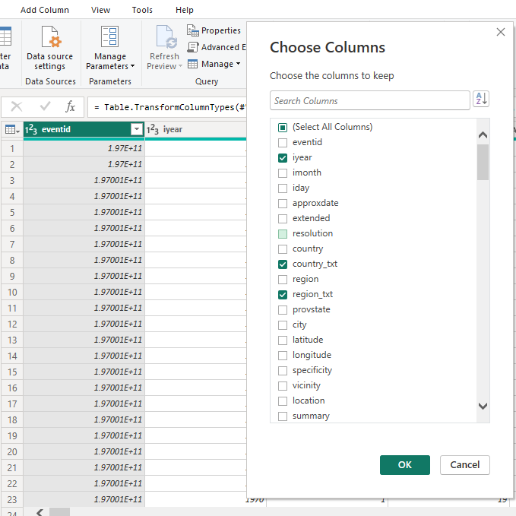

Transform the data souce, iyear, country_txt, region_txt, success, attacktype1_txt, targettype1_txt, weapontype1_txt, gname into a new source. The new data source was renamed as “Global Terrorism Final Dataset”. Then the other sub data source was disabled.

### Edit blank rows

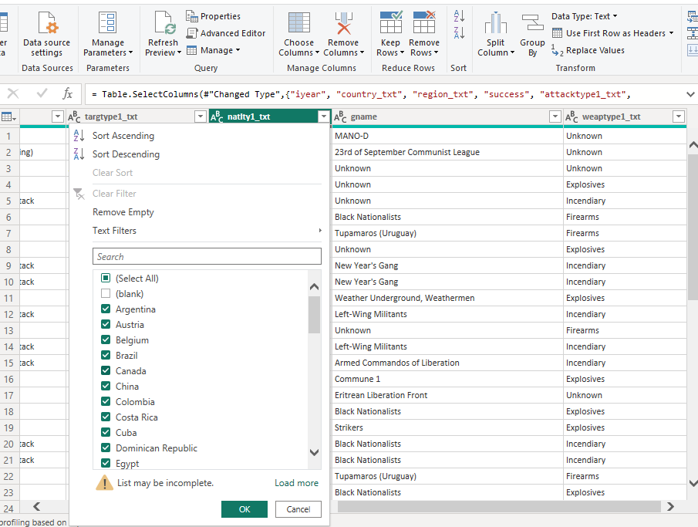

Edit natlty1_txt by unselecting the blank rows. Then load the dataset.

### Region analysis:

Utilise maps to display the distribution of terrorist activities across the Middle East, Europe, Africa, and Asia.

* **Succes Rates:**

Create bar charts to compare success rates of terrorist attacks in each region , highlightingthe highest rates.

* **Terrorist Group Names:**

Use line charts to visualise the prevalence of terrorist Groups in each region.

**Target Type:**

Employed pie chart to demonstrate the top 5 targets if terrorist attacks in each region , such as civilian populations, public gatherings , government, institutions, and military installations.

**WeaponsUsed:**

Genereted visuals like pie chart to showcase the types of weapons commonly employed in terrorist attacks across regions, including explosives , firearms, and improvised explosive devices.

By leveraging Power BItools, created interactive dashboards that offer a comprehensive overview of global terrorism trends, facilating data-driven decision-making and enhancing understanding of security challenges worldwide.

## Dashboard

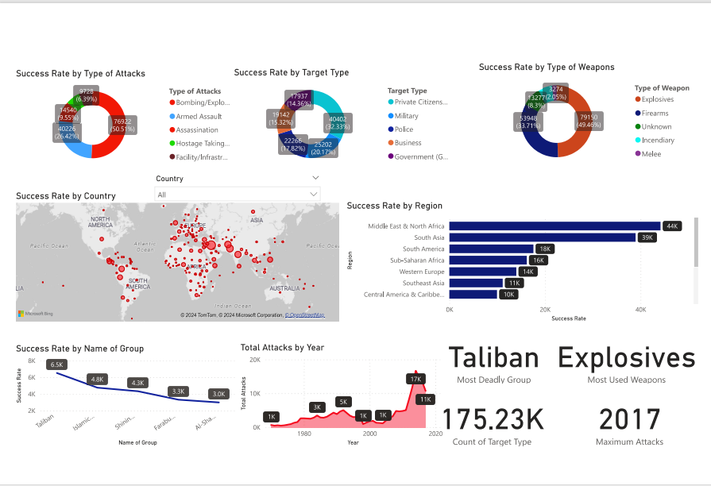

## CONCLUSION

In conclusion, Global Terrorism is a critical aspect of modern society. Apps utilising Power BI has provided invaluable insights into various facets of its operation. By leveraging Power BI tools,created interactive dashboards that offer a comprehensive overview of global terrorism trends, facilating data-driven, decision-making and enhancing understanding of security challenges worldwide.The integration of Power BI into Gobal Terrorism frame work exemplifies the power of leveraging advanced tools in today’s competitive regions and decision-making.

**FUTURE SCOPE**

Future scopes in Global Terrorism using Power BI is promising and multifaced. Firstly, enhancing the deapth and breath of data analysis can provide invalueable insights into regions,country, and year. From integrating data from various sources such as target types, attack types, weapon types , Terrorism can gain a comphrehensive understanding for user preferences and tailor its services accordingly. By leveraging Power BI tools,created interactive dashboards that offer a comprehensive overview of global terrorism trends, facilating data-driven, decision-making and enhancing understanding of security challenges worldwide.The integration of Power BI into Gobal Terrorism frame work exemplifies the power of leveraging advanced tools in today’s competitive regions and decision-making.

In the future as technology continues to advance and data volumes grow exponentially , the scope for business analysis using Power BI within Powered Global Terrorism will doesn’t expand.

**REFERENCES**

<https://mavenanalytics.io/project/908>

<https://www.linkedin.com/pulse/global-terrorism-database-dashboard-elias-dabbas>

## LINK

[**https://github.com/sreejaradha/Power-BI-Powered-Global-Terrorism**](https://github.com/sreejaradha/Power-BI-Powered-Global-Terrorism)